"Why I felt it was right to progress your studies around sustainability and what I hope it will open up for my career"

By Laura Gelder-Robertson, Director at Glow Innovation

Having worked in Innovation for 20 years, mainly in Retail, Pharmaceuticals, FMCG, finance, and social enterprise, ‘Sustainability’ increasingly comes up as a topic for discussion and to design around.

As a mum with two young kids, two of my key insights from life during lockdown were:-
1) how important the natural world and environment is, and 2) how interconnected our health, wellbeing, economies and business are as global citizens.

Last Summer, I spent time picking up litter in the forest to help my eldest earn her first Blue Peter Badge, I stopped under the cool shade of pine trees in the extreme heat, I appreciated the deafening dawn chorus of the birds whilst out running in the mornings.

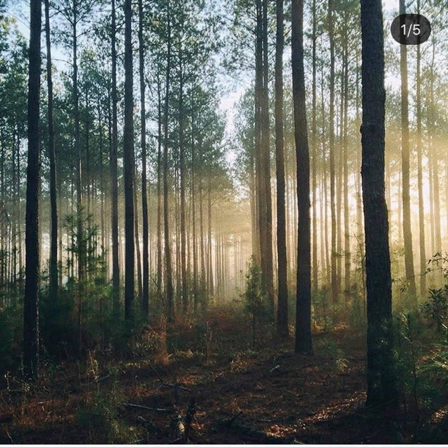

‘Pine forest’ by Circle of Pines on Instagram

And I started to read a lot more about Climate Change.

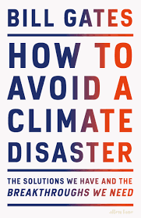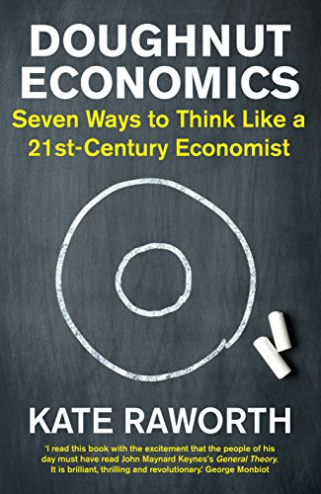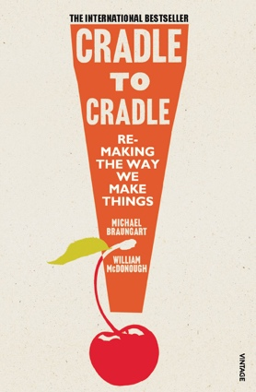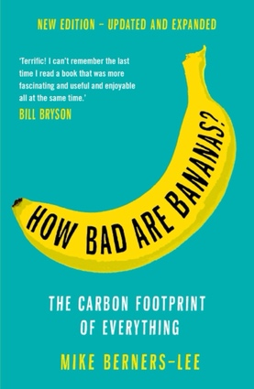

One of my old university friends, Rachel Skinner recently took over as the President of the ICE (Institute of Civil Engineers) and in her inaugural speech, she outlined her Vision for “Shaping Zero.” I was really struck by her stark depiction of how urgent action is required for us to have a chance of achieving Net Zero emissions by 2050.

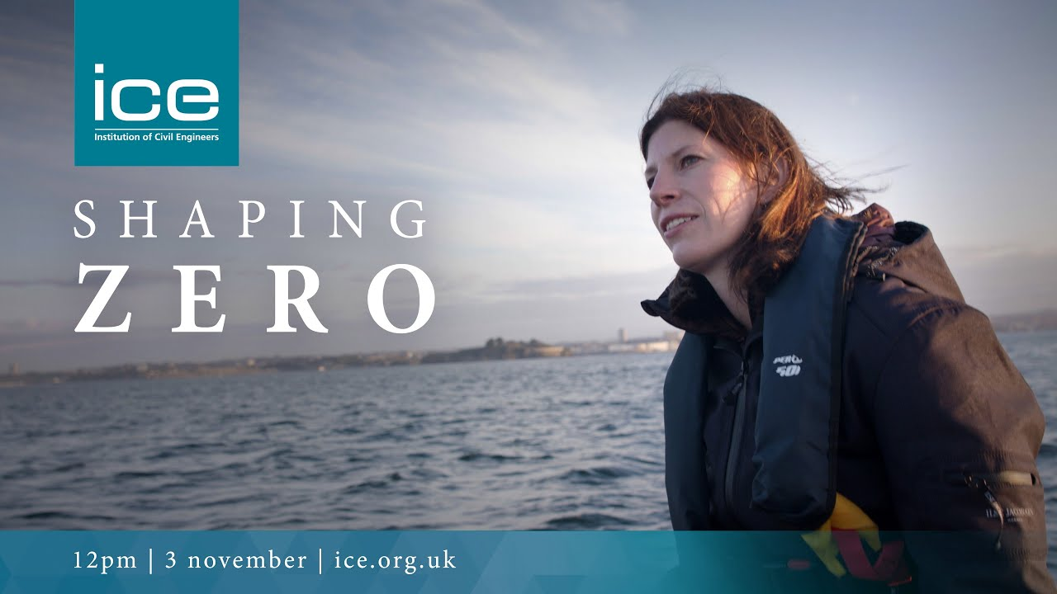

Rachel Skinner, President of ICE’s Inaugural Address

I watched David Attenborough raise awareness of climatic shifts in, “7 Worlds: 1 Planet.” Then I watched the plant-based diet documentary on Netflix, “Game Changers”. I read Kate Rayworth’s, “Doughnut Economics” to learn about a more equitable and sustainable way for us to recover from COVID.

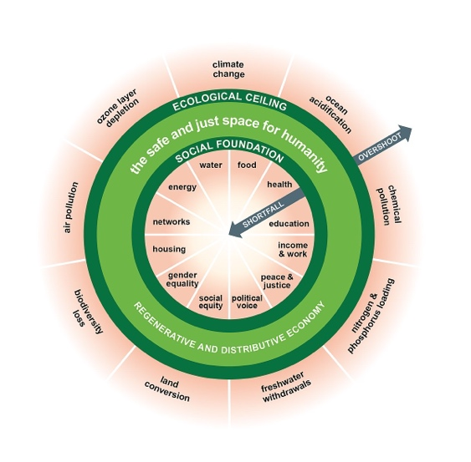
‘Doughnut Economics Model’ by Kate Raworth; ‘Doughnut’ by Alice Pasqual on Unsplashed

And I knew I had a doughnut-hole sized gap in my knowledge. I knew WHY urgent action’s needed around Climate Change, but not HOW I could affect it through Innovation?

So, I decided to mind the gap. I started broadcasting on social media and telling everyone I know, family, friends, colleagues that I was really interested in how Innovation could play a key part in Climate Change.

People started recommending more books, inviting me to webinars and conferences. I went to the excellent British-Swiss Chamber of Commerce’s Sustainability Conference in Switzerland (another joy of lockdown – virtual events) where I met the Eden Project’s Planet Mark Team, who invited me to an SME training to assess emissions for my business and create my own Sustainability Action Plan.
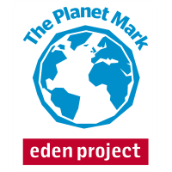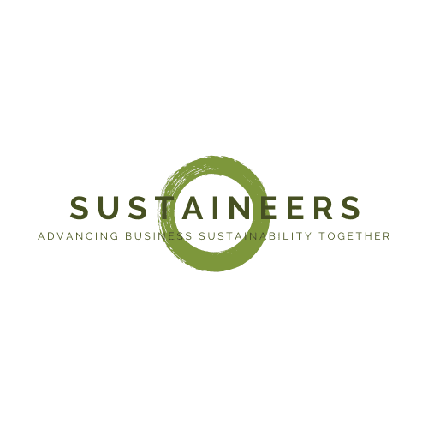

Leading edge Networks for Sustainability

I did it and made some great contacts who were equally passionate about Climate Change. One of them invited me to talk to a group of alumni from Cambridge University’s Climate Change & Sustainable Leadership Course about Innovation, which I did. I was really struck by how welcoming, encouraging and open the ‘Sustaineers’ were. There was a real sense that we’re in this together and the sooner people understand and engage with Net Zero, the better.

That inspired me to enrol for the Course myself, which I’m currently studying. It’s a steep learning curve in all areas of Business Management, because achieving as far-reaching and profound a challenge as Net Zero emissions requires systemic, Business Model-level change. But it’s absolutely fascinating.

Have I found my HOW yet? Not quite, I’m only part-way through but I have no doubt that through diving deeply into the latest research and best-practise business case studies, alongside a network of fellow students who are wise and open to collaboration, that the CISL course will change my life. How? Watch this space!

579 words (excluding references)

http://www.glowinnovation.com/
https://vimeo.com/475498061.
https://www.bbc.co.uk/iplayer/episodes/p07dzjwl/seven-worlds-one-planet
https://gamechangersmovie.com/
https://www.bbc.co.uk/ideas/videos/could-circular-economics-fix-the-planet/p06j8f32
https://www.bscc.co.uk/
https://www.planetmark.com/
https://www.cisl.cam.ac.uk/education/learn-online/business-and-climate-change-towards-net-zero-emissions-online-short-course.
https://sustaineers.org/

